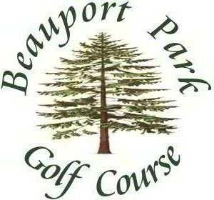

FIXTURE LIST 2015

March

Sun 22nd Captain’s Drive-in and 9-hole Stableford
Sun 29th Stableford

April

Sun 5th April Stableford OoM
Sun 12th April Medal OoM
Sun 19th Fullers London Pride Gold Medal OoM
Sun 26th Lombard Qualifier OoM

May

Sun 3rd PRO-PRO Challenge
Sun 10th May Stableford OoM
Sun 17th Red Cross Bowl
Sun 24th May Medal OoM
Sun 31st No Alibi – Mulligan Stableford

June

Sun 7th June Medal OoM
Sun 14th Russian Pairs
Sun 21st June Stableford OoM
Sun 28th Captain’s Day OoM

July

Sun 5th July Medal & SCGU Centenary Jug Final OoM
Sun 12th July Stableford OoM
Sat 18th/Sun 19th Club Championship OoM
Sun 26th Bert James Greensomes

August

Sun 2nd Skin’s Qualifier OoM
Sun 9th August Medal OoM
Sun 16th August Stableford OoM
Sun 23rd The Legend – Better-Ball
Sun 30th Secretaries Cup OoM

September

Sun 6th September Stableford OoM
Sun 13th Nassau OoM
Sun 20th September Medal OoM
Sun 27th Bradnam Pairs-Daily Mail Qualifier

October

Sun 4th October Medal OoM
Sun 11th Blind Date NHQ
Sun 18th October Stableford OoM
Sun 25th Top Gun Shootout

OoM = Order of Merit NHQ = Non Handicap Qualifying

